Company Description
The Informatique has been operating for over 20 years in market the information technology. His more than 20 successful cases demonstrate its seriousness and technical and operational competence in providing technological solutions based on software: desktop, web and mobile. The Informatique always believed that the technology is a powerful tool and its ability to solve problems of day-to-day could be leveraged to solve major world problems, especially those directly affected the quality of life of disadvantaged. With a visionary and innovative spirit, the Informatique sought an opportunity from technological solutions, allied human development, reducing environmental impacts, and revenue generation. With this goal, the your CEO, in 2010, began his master at the Federal University of Ceará - UFC, and created the first version of the model named "e-lixo Sustentável". Throughout more than two years of field research, the model has matured, and with a new perspective, won the brand SELLETIVA and became a model business with return potential on investment, and also with real potential for national and international expansion.
Awardss
The model SELLETIVA received several awards in recent months:
• Winner of the CHALLENGE BRAZIL - 2012, regional Ceará/Piauí/Maranhão. In Fortaleza-CE (FIEC) (2012);
• 2nd place in the challenge Greenpeace/Porto Digital for Sustainability of Cities. In Recife-PE (2012);
• 4th Place in Porto Digital Challenge for Cities Ecointeligentes. In Recife-PE (2012);
• Finalist (top 10 enterprises in the Northeast) in Challenge UKTI (UK) / Porto Digital. In Recife-PE (2013);
• Incubated at C.A.I.S. do Porto. In Porto Digital (Recife-PE).
Business Model - SELLETIVA

Tune with the growing environmental awareness of Brazilian society, with the strength of collaborative networks, and supported by a federal environmental legislation (Law 12.305/2010) that turns into crime disposal environmentally incorrectly called junk electronics. The Informatique, through the model SELLETIVA propose a management model informational able to integrate the complete chain of reverse logistics of electronics equipment. Thus, to render services to industries, trade (stores), recycling companies, recycling cooperatives, and consumers regarding disposal of your electronic waste, acting proactively in relation to Law 12.305/2010. The SELLETIVA platform will create a chain environmentally friendly and legally perfect, legally endorsing all involved parties with share responsibility imposed by law. The SELLETIVA will encourage the end user to dispose of your waste electronics at collection points previously registered, or to schedule a home gathering. Cooperatives of collectors and collection companies will have access to information on where the junk to be discarded, what type and volume, thereby optimizing their routes and reducing its costs. In turn, the recycling companies will receive a high volume of electronic waste, increasing its margin. At the end of the process, the manufacturing industry electronic equipment will receive a certificate / statement, with legal value, attesting to dispose of a quantity of the wastes in an environmentally correct. In simplified form, this action is shown below.
Market e Concurrence
Studies conducted by the Institute for Applied Economic Research - (IPEA), Brazil loses about U.S. $ 3,6 billion per year by not recycling, appropriately, their solid waste. According to data released by the Collectors´s Cooperative - DF in its Business Plan (2012), Brazil currently has only 8% of municipal recycling program, which serves about 12% of the national population. It is important to remember that industry and trade are not prepared to support the demand for reverse logistics imposed by environmental legislation. With that, arises space to provide service that meets this gap, keeping the entrepreneur focused on your business. The opportunity is presented at its best moment, anticipating the super demand that will be generated due to the statutory requirement accompanied by financial penalties. Of the main targets imposed by the federal government - regulated by Decree 7.404/2010, stand out:
- Submit sectoral agreement with the Ministry of Environment (MMA) to December/2013;
- Collect 17% of the volume placed on the market during the year 2013;
- Cover 100% of the municipalities having population over 80 thousand inhabitants.
Currently, there is a solution that addresses the entire reverse logistics chain with an initial focus on home users. A little competition in this sector still operates with piecemeal solutions and punctual.
Business Strategy and Marketing
In its first three years of operation, the company aims to become a regional leader in the Northeast, reaching 30 % market share in relation to the total waste disposed of in an environmentally correct. Acting in at least two major northeastern capital, and in the fifth year, an estimated 17 % in its share in the domestic market with entry across the metropolitan region of São Paulo. As commercial strategy in the short term, the model SELLETIVA it will become economically viable by charging a percentage on collecting of surplus provided to the actors of the chain. As commercial strategy in the medium term, checking copy of the sale of environmentally friendly disposal for industry and commerce. As commercial strategy in the long term, market information about the reasons for the discharge, and also in the marketing of the franchise in other regions. The main strategies are:
1 ) Geographic: start its activities with a focus on two capitals of the Northeast : Fortaleza and Recife. In the case of Reef, by being incubated in C.A.I.S. do Porto, perform actions focused initially on the region covered by the Porto Digital;
2 ) Population: the next market to be conquered is concentrated in the state of São Paulo, due to the high concentration of electronic equipment industries, and its large consumer population;
3) Behavioral: depending on the cultural and behavioral change in Brazilian society, with growing "green wave" of Corporate Social Responsibility - BE, and legal enforcement.
How Marketing Strategy, will initially be focused networks of collaboration, will be used preferentially Digital Marketing, with all its strengths. To generate the data base about e-waste. How differentiated strategy, customers will receive promotional bonuses and discounts in shops previously registered.
Necessary Investments
The intended investment is U.S $ 690,000.00, which will be primarily devoted to the actions of Marketing and P&D (HR, Outsourced Services, Infrastructure and Operating Expense) to generate a competitive advantage. Including, with barrier to new entrants.
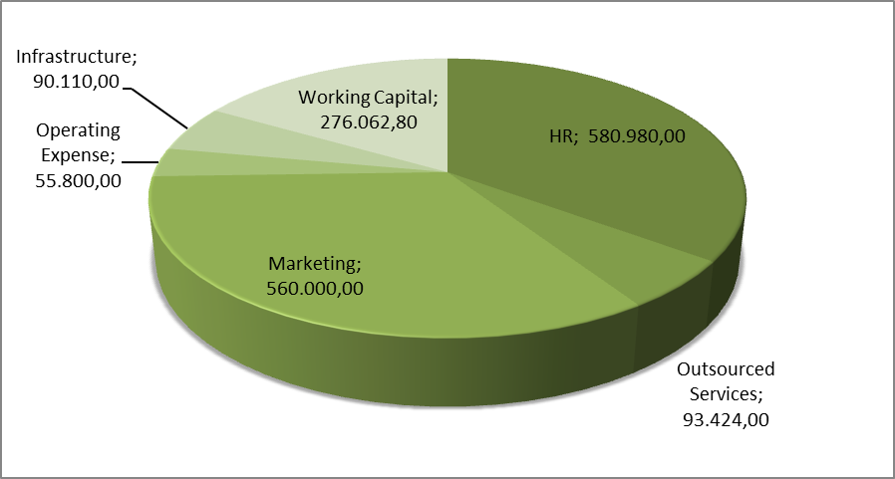
Financial Projections

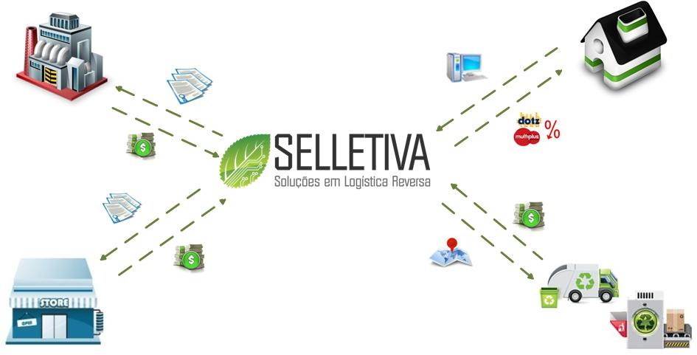
Projected Operating Results of SELLETIVA
Industry
Little Users
Trade
Services (Chain RL)
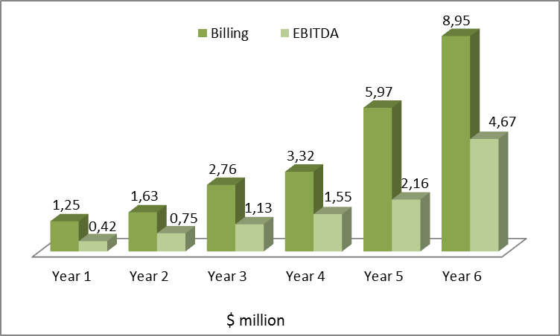
Our Team
Sérgio Clério Jorge Moreira, Ms.: CEO. Master in Business Administration and Controlling - UFC. Bachelor of Computing from the UFC. Areas of expertise: Strategic Management / Technology and Process Optimization.
Rose Jeokellyane do Valle Moreira, Ms.: Master in Business Administration and Controlling - UFC. Bachelor in Tourism by UNIFOR. Areas of expertise: Environmental Management and Innovation.
Luiz Alves de Lima Neto, Ms.: Master Teleinformática the UFC. Engineer trained in UNIFOR PMP certified. Areas of expertise: Project Management and Business Development.
Daniel Freitas Colaço: Master in Teleinformática the UFC. Engineer graduated from the UFC. Areas of expertise: Management RD & I.

