Company Description
For over 20 years Informatique has operated in the IT market and its more than 20 successful cases demonstrates seriousness and technical and operational competence in providing technological solutions based on software: desktop, web and mobile. Informatique always believed that the technology is a powerful tool and its ability to solve problems of day-to-day could be leveraged to solve major world problems, especially those that directly affect the quality of life of disadvantaged people. With a visionary and innovative spirit, Informatique sought an opportunity that, from technological solutions, allied human development, reduction of environmental impacts, and revenue generation. With this goal, its CEO, in 2010, began his master at the Federal University of Ceará - UFC, and created the first version of the model named "e-lixo Sustentável". During more than two years of field research, the model has matured, and under a new perspective, won the brand SELLETIVA and became a business model with potential return of investment (ROI), and also with a real potential for national and international expansion.
Awards
The business model SELLETIVA has received several awards:
• Two grants awarded for research and development in 2014, totalizing $ 260,000.00;
• Brazilian Northeast Top 5 enterprises in UKTI Challenge (UK) / Porto Digital. In Recife-PE (2013);
• Winner of the CHALLENGE BRAZIL - 2012, regional Ceará/Piauí/Maranhão. FIEC. In Fortaleza-CE (2012);
• 2nd place in the Greenpeace/Porto Digital Challenge for Sustainability of Cities. In Recife-PE (2012);
• 4th Place in Porto Digital Challenge for Eco Smarts Cities. In Recife-PE (2012);
Business Model - SELLETIVA

Tuned with the growing environmental awareness of Brazilian society, with the strength of collaborative networks and supported by a federal environmental legislation (Law 12.305/2010) that qualifies as crime the incorrectly environmentally disposal of the so called junk electronics (e-waste), Informatique propose an informational management model able to fully integrate the reverse logistics chain of electronics equipment. Therefore Informatique will provide services to industries, retails, recycling companies, waste collectors' cooperatives and consumers regarding the correct disposal of their electronic waste, acting proactively in relation to Law 12.305/2010. SELLETIVA platform will create an environmentally friendly chain and legally perfect, endorsing all involved parties with share responsibility imposed by law. SELLETIVA will incentive the end user to dispose of your electronics waste at collection points previously registered or to schedule a home gathering. Waste collectors' cooperatives and recycling companies will have access to information like: where the e-waste is, what its type and volume, and thereby optimizing their routes and reducing its operational costs. Consequently, the recycling companies will receive a high volume of electronic waste, increasing its financial income. At the end of the process, the manufacturing industry of electronic equipment’s will receive a certificate / statement, with legal value, attesting the environmentally correct disposal of a certain quantity of the electronic wastes. In a simplified view, SELLETIVA plays as depicted bellow:
Market and Concurrence
According to the Brazilian Institute for Applied Economic Research - (IPEA), Brazil loses about U.S. $ 3,6 billion per year by not appropriately recycling, their solid waste. According to data released by the Collectors´s Cooperative - DF in its Business Plan (2012), Brazil currently has only 8 % of municipal recycling program, which serves about 12 % of the national population. Besides it is quite important to emphasize that industry and retails are not prepared to support the demand for reverse logistics imposed by environmental legislation. This leads to a service that meets this gap, keeping the entrepreneur focused on his business. The opportunity is presented at its best, just in anticipation of the super demand that will be generated as a function of legal imposition and financial penalties. Of the main targets imposed by the federal government - regulated by Decree 7.404/2010, stands out:
- Submit sectoral agreement with the Ministry of Environment (MMA) to December/2013;
- Collect 17% of the volume placed on the market during the year 2013;
- Cover 100% of the cities with population over 80 thousand inhabitants.
Currently, there is no solution that addresses the entire reverse logistics chain with an initial focus on home users. A little competition in this sector still operates with fragmented and point approaches.
Business Strategy and Marketing
In its first three years of operation, the company aims to become a regional leader in the Northeast, reaching 30% of market share in relation to the total waste disposed environmentally correct, acting in at least two major northeastern capitals. In the fifth year, estimates a 17% of market share in the domestic market with entry across the metropolitan region of São Paulo. The short-term commercial strategy is to make SELLETIVA economically viable by charging a percentage on collecting surplus provided to the actors of the chain. In the medium term, SELLETIVA will focus on industry and retails issuing certification of environmentally friendly e-waste disposal, in accordance to Federal law. In the long term, market information about disposal reasons (what why, when, who and where) will be offered to Industry and retails, beyond the commercialization of the franchise in other regions. The main strategies are:
1 ) Geographic: starts its activities focusing on two capitals of the Northeast : Fortaleza and Recife.
2 ) Population: the next market to be conquered is concentrated in the state of São Paulo, due to the high concentration of electronic equipment industries, and its large consumer population.
3) Behavioral: depending on the cultural and behavioral changes in Brazilian society, with growing "green wave" of Corporate Social Responsibility - BE, and legal enforcement.
As a Marketing Strategy, SELLETIVA will initially be focused on collaborative networks, by means of digital marketing and all its strengths. Through these networks it will be generated the data base about e-waste. As a differentiated strategy, customers will receive promotional bonus and discounts in retails and brands previously registered.
Necessary Investments
The aimed investment is U.S $ 623,058.00, which will be primarily devoted to the actions of Marketing and R&D (HR, Outsourced Services, Infrastructure and Operating Expense) to generate a competitive advantage, including barriers to new entrants.
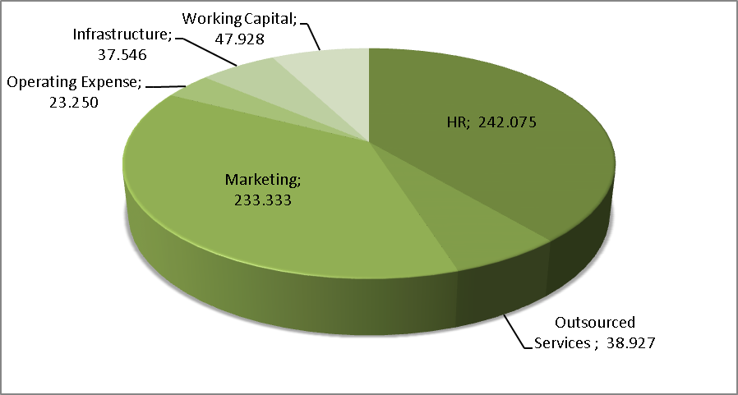
Financial Projections

Projected Operating Results Considering 5 Annual Reinvestments
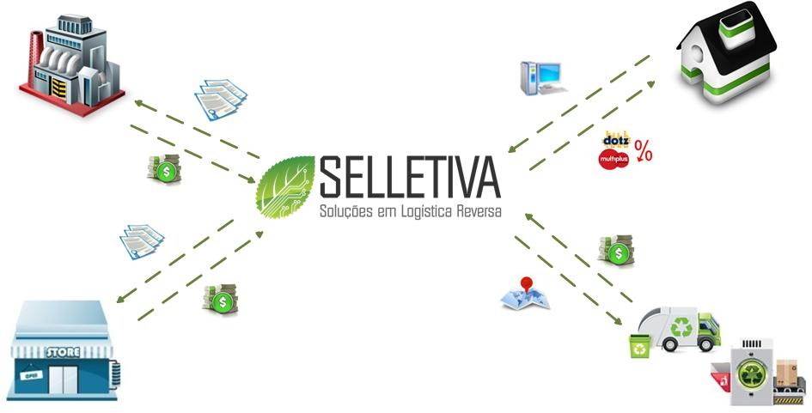
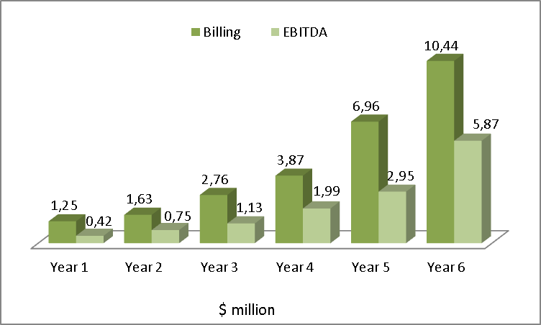
Industry
End Users
Retails
Services (Chain RL)
IIR: 43%. Discounted Payback: 6,2 years. NPV: 12,791,000.00
Our Team
Sérgio Clério Jorge Moreira, Ms.: CEO. Master in Business Administration and Controlling at UFC. Bachelor of Computing at UFC. Areas of expertise: Strategic Management / Technology and Process Optimization.
Rose Jeokellyane do Valle Moreira, Ms.: Master in Business Administration and Controlling at UFC. Bachelor in Tourism at UNIFOR. Areas of expertise: Environmental Management and Innovation.
Luiz Alves de Lima Neto, Ms.: Master in Teleinformatics at UFC. Electronic Engineer at UNIFOR. PMP certified. MBA in Business Management at IBMEC. Areas of expertise: Project Management and Business Development.
Daniel Freitas Colaço: Master in Teleinformatics at UFC. Engineer graduated at UFC. Areas of expertise: Research, development and innovation.

